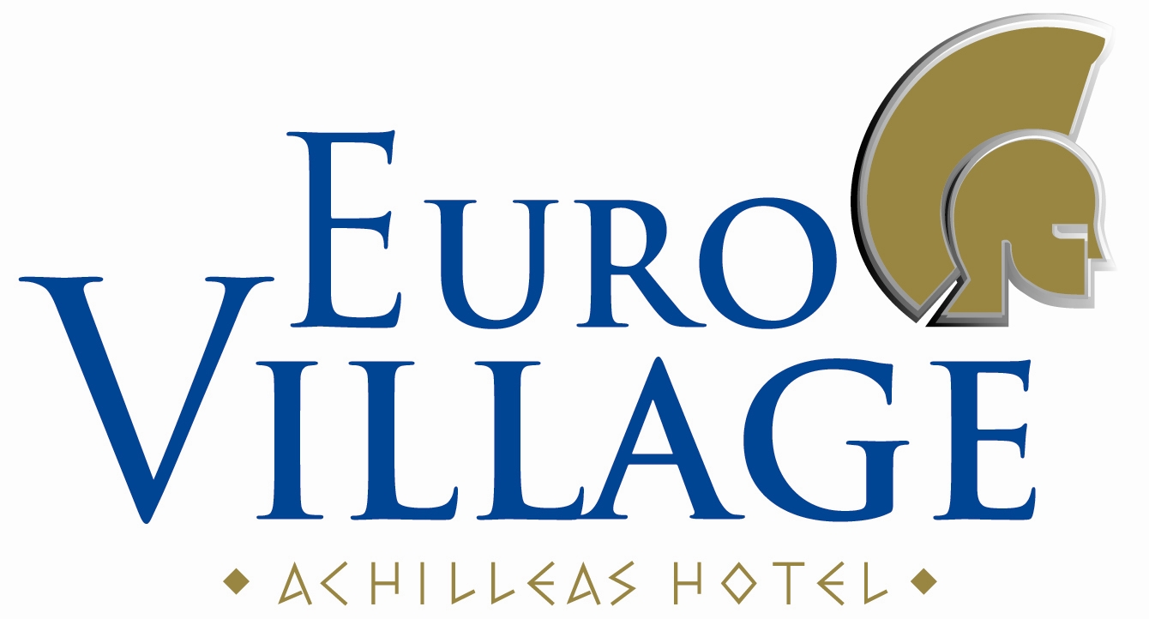

AMENITIES PROGRAMME FOR SEASON 2017

HOTEL DESCRIPTION:

333 FURNISHED ROOMS WITH BALCONY OR TERRACE.

STANDARD TWIN ROOMS: BATH, WC, SAT TV, REFRIGERATOR, DIRECT DIAL TELEPHONE, HAIRDRYER, SAFE BOX, AIR CONDITION, BALCONY OR TERRACE, WITH GARDEN VIEW OR POOL VIEW OR SIDE SEA VIEW.

STANDARD TWIN SEA VIEW ROOMS: BATH, WC, SAT TV, REFRIGERATOR, DIRECT DIAL TELEPHONE, HAIRDRYER, SAFE BOX, AIR CONDITION, BALCONY OR TERRACE, WITH DIRECT SEA VIEW.

SUPERIOR TWIN ROOMS: SOFA & SMALL TABLE, LARGE FLAT SCREEN SAT TV, REFRIGERATOR, DIRECT DIAL TELEPHONE, HAIRDRYER, SAFE BOX, AIR CONDITION, FREE WI-FI, WALK-IN SHOWER, BATH SLIPPERS, BATH AMENITIES, COMPLIMENTARY TEA/COFFEE TRAY WITH BOILER, BALCONY OR TERRACE, WITH GARDEN VIEW OR SEA VIEW.

FAMILY ROOMS: THE SAME AS STANDARD TWIN ROOMS WITH ONE EXTRA BED ROOM WITH CONNECTING DOOR.

RECEPTION, MAIN RESTAURANT (AIR-CONDITIONED), THEMED RESTAURANT (AIR-CONDITIONED), MAIN BAR, POOL/SNACK BAR, BEACH BAR (OPERATES IN MID. & HIGH SEASON), INTERNET CORNER (ON CHARGE) & WI-FI HOTSPOTS (ON CHARGE), LOBBY, TV LOUNGE (SATELLITE).

GYM, TENNIS COURT, BEACH SOCCER, BASKETBALL COURT, MINI GOLF, BEACH VOLLEY, DARTS, GAMES ROOM, TABLE TENNIS.

A LARGE SWIMMING POOL WITH A SEPARATE CHILDREN’S POOL (ALL WITH FRESH WATER), CHILDREN’S MINI CLUB, CHILDREN’S PLAYGROUND, AN AMPHITHEATRE
AND A STAGE, DISCO NIGHT CLUB (AIR-CONDITIONED).

CURRENCY EXCHANGE, CAR RENTAL, MOTORBIKES & BIKES RENTAL, MINI MARKET.

TOWELS : FOR POOL & BEACH ON CHARGE (UPON AVAILABILITY, DEPOSIT REQUIRED).
BEACH : UMBRELLAS & SUN BEDS ON CHARGE (UPON AVAILABILITY).

THE ALL INCLUSIVE AMENITIES:

- RECEPTION (24 HOURS).

- MAIN RESTAURANT :BREAKFAST(07:30-09:30), LUNCH (12:30-14:00),
DINNER (19:00-21:30) ALL MEALS & DRINKS SERVED ON BUFFET STYLE, SELF SERVICE.
OFFERS WATER, SOFT DRINKS, JUICES, DRAUGHT BEER & WINE.

- THEMED RESTAURANT : MID MAY–MID OCTOBER, RESERVATION IS REQUIRED, UPON AVAILABILITY.
DINNER (18:30 – 21:30) BUFFET STYLE, SELF SERVICE.
OFFERS WATER, SOFT DRINKS, JUICES, DRAUGHT BEER & WINE.

- MAIN BAR (operates 17.00-01.00) SELF SERVICE. OFFERS WATER, SOFT DRINKS, JUICES, BEVERAGES (FILTER COFFEE, TEA, MILK) AND ALCOHOLIC DRINKS (DRAUGHT BEER & WINE, OUZO, BRANDY, WHISKY, VODKA, TEQUILA, GIN AND WHITE RUM).

- POOL/SNACK BAR (operates 10.00-18.00) SELF SERVICE. OFFERS DAILY, SNACKS SUCH AS
DIFFERENT KIND OF PIES AND SANDWICHES, PIZZA IN SLICES, WATER, SOFT DRINKS,
JUICES, BEVERAGES (FILTER COFFEE, TEA, MILK) AND DRAUGHT BEER & WINE.
FROM 12.00 TILL 15.00: GREEK PITA, HOT DOGS & FRENCH FRIES (with ketchup, mayo & other sauces).
“COFFEE TIME” FOR ONE HOUR EVERY AFTERNOON ESCORTED BY CAKES & COOKIES.

- BEACH BAR (operates 10.00-18.00, JUNE – SEPTEMBER). SELF SERVICE. OFFERS SNACKS SUCH AS DIFFERENT KIND OF PIES AND SANDWICHES, PIZZA IN SLICES, WATER, SOFT DRINKS, JUICES, BEVERAGES (FILTER COFFEE, TEA, MILK) AND DRAUGHT BEER & WINE.

- ICE CREAM IN CONES SERVED FROM 10:00 TILL 18:00 IN POOL BAR
AND DURING LUNCH & DINNER IN RESTAURANTS.

- ALL SPORTS FREE OF CHARGE.

- SWIMMING POOL: UMBRELLAS & SUN BEDS FREE OF CHARGE (UPON AVAILABILITY).

- ENTERTAINMENT: FULL ANIMATION PROGRAMME (6 DAYS/WEEK).
DISCO : OPERATES JUNE - SEPTEMBER, SEVERAL TIMES/WEEK, ON CHARGE.

THE ALL INCLUSIVE PROGRAMME IS VALID FROM 07.30-23.00
AND INCLUDES LOCALLY PRODUCED DRINKS.

